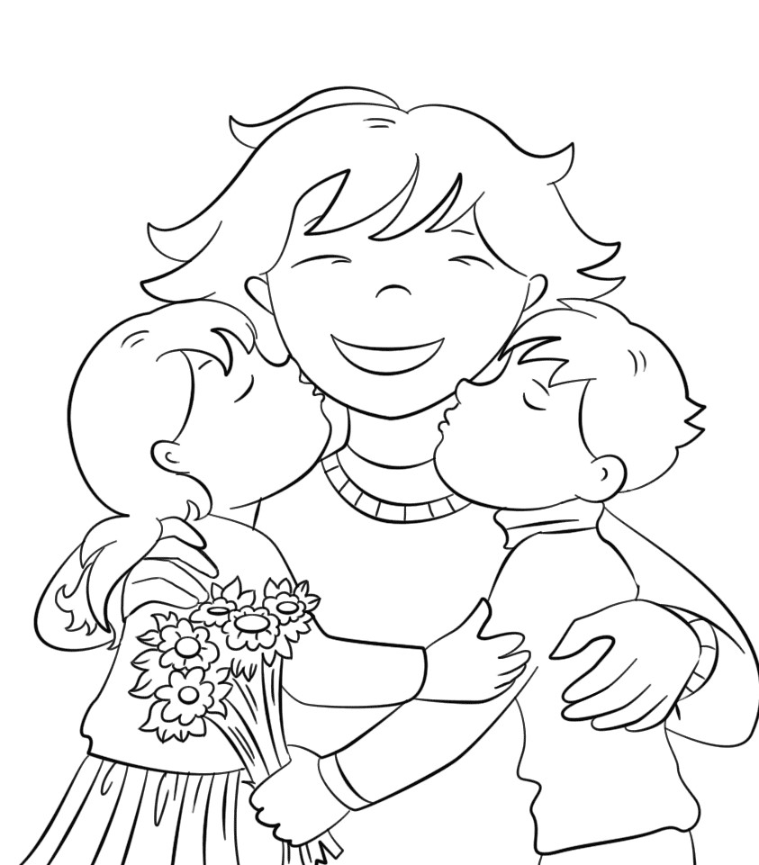
MAMI, RAD/-A TE IMAM, KER ________________________________
________________________________________________________.

